A1-20181-SQL-DBS301

DUE DATE: Nothing will be accepted after this date. It will get a zero

**Due BEFORE MIDNIGHT on the FRIDAY of WEEK 7 – no other extensions**

**PLAGIARISM**   
When you submit an assignment, you are saying that the submission is your own work or your groups own work and as such you wish to be given credit for the work.

Occasionally, it may be necessary to ask someone for a small amount of help. You are permitted to do so, provided you meet the following two conditions.

1 You acknowledge the help on the work you hand in, including explaining the work or portion of the work done or assisted by another person.

2 You understand the work that you hand in, so that you could explain the reasoning behind the parts of the work done for you or assisted by another.

Any other assistance by another person constitutes a violation called plagiarism and will be treated as such.

If two submissions exist, that are essentially the same, then both submissions cannot possibly make the claim that the work is "solely their own". This is a serious matter and is considered plagiarism. It is recorded in accordance with College policy and may result in a penalty such as expulsion from the College. Please do not put yourself in this position. Plagiarism is very easy to detect.

**Understanding what group works means**

This assignment can be done in groups. Ideal might be 2 to 4, but is not limited to that number.

It is suggested that you ALL do it individually and then meet to compare answers. Those not doing the work should be dropped from your group.

**VERY IMPORTANT:**

Being part of a group is the same as being a part of a team for these assignments. When you submitted your work as part of a group you are saying that:

you understood what was submitted and that you fully participated with ALL the group members.

It does not mean letting others do your work for you.

It does not mean watching the others do the work.

For your full participation, you get a mark equal to all the others in the group. If on the test, which is very much like the assignment, you cannot answer the questions, it strongly indicates that you didn’t participate and understand the assignment but depended on others for the mark you received. That is very much like submitting their work and claiming it is your work.

Members in group and which members account was the work done on. ___________________

**Anyone not in this list at submission time, cannot be added to the group later**

|  |  |  |  |
| --- | --- | --- | --- |
| Name | Student ID | Email address | Oracle ID |
|  |  |  |  |
|  |  |  |  |
|  |  |  |  |
|  |  |  |  |
|  |  |  |  |
|  |  |  |  |
|  |  |  |  |

________________________________________________________________________

The above list of names acknowledges you understand.

INSTRUCTION:

1 Please rerun the scripts CMC and demo. They have been updated.

2Rename this WORD file A1-xxxxx where xxxxx is replaced with one of your email account name, not the whole email. If you are in a group pick one of them.

3 When finished email this back to me and CC everyone in your group as proof it was sent.

4 The following tables are used for this assignment. You have loaded the 2 scripts already.

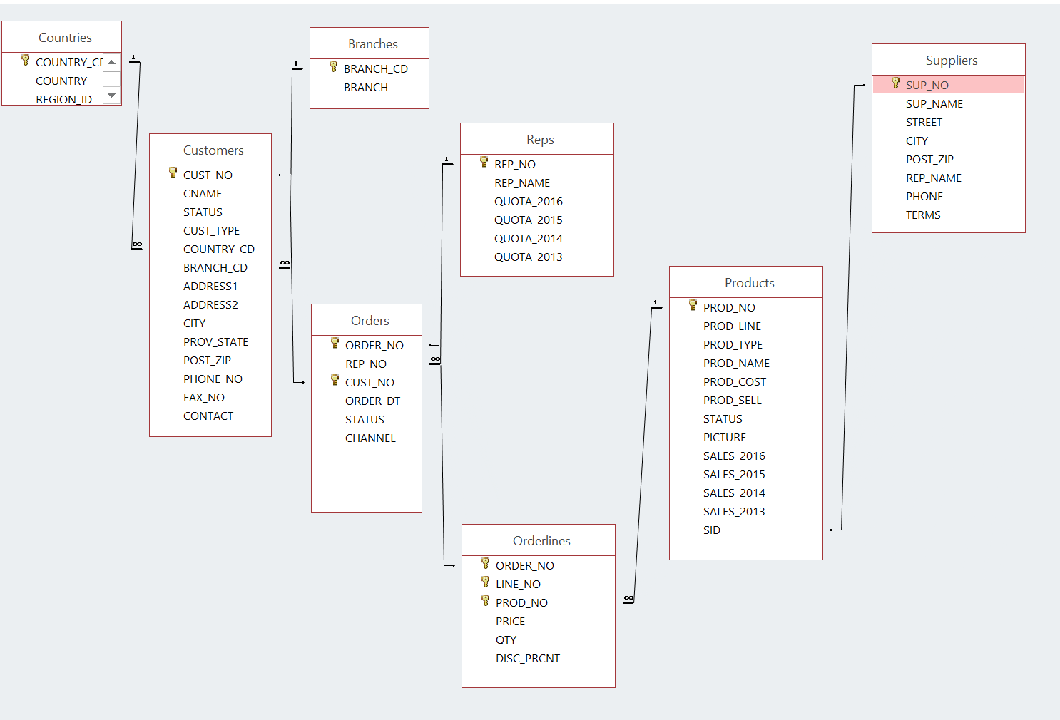

The above comes from the script CMC

NOTE:

If any output goes on for more than 100 lines, only cut and paste the first 100 or so. I don’t want to get this word document too big.

**ALL WORK MUST BE DONE ON SENECA’S ORACLE ACCOUNT**

**SQL that does not follow easily readable standard formats will not be marked.**

1 Display the customer number, customer name and country code for all the customers that are in the UK. The country code for United Kingdom is UK.

Please note that the user could have used UK, Uk, uk, uK. Your SQL must allow for various user inputs of the code. They are not entering the country name. **(Abrar)**

**SQL:** **SELECT CUST_NO,CNAME, COUNTRY_CD FROM CUSTOMERS**

**WHERE UPPER(COUNTRY_CD) LIKE UPPER('Uk%');**

**OUTPUT:**

**CUST_NO CNAME COUN**

**---------- ------------------------------ ----**

**1025 Fresh Air Co 5 UK**

**1026 GO Outlet London 13 UK**

**1065 Trees to Seas Ltd UK**

**1089 Rock Steady 3 UK**

**1111 Wally Mart 1 UK**

**1112 Wally Mart 2 UK**

**1120 GO Outlet London 13 UK**

**1121 GO Outlet Manchester 13 UK**

**1127 Fresh Air Co 1 UK**

**1128 Fresh Air Co 2 UK**

**1129 Fresh Air Co 3 UK**

**1134 Breathe Free ltd UK**

**12 rows selected.**

2. For any GO Outlets list the customer number, customer name and order number if they ordered any of these products -- 40303, 40301, 40306. Put result in customer number order. **(jasmeet)**

**SQL:**

SELECT DISTINCT(C.CUST_NO), C.CNAME,O.ORDER_NO

FROM CUSTOMERS C

INNER JOIN ORDERS O ON C.CUST_NO = O.CUST_NO

INNER JOIN ORDERLINES OL ON O.ORDER_NO = OL.ORDER_NO

WHERE OL.PROD_NO IN ( 40303, 40301, 40306) AND UPPER(C.CUST_TYPE) = UPPER('GO OUTLET')

ORDER BY C.CUST_NO;

**OUTPUT:**

CUST_NO CNAME ORDER_NO

---------- ------------------------------ ----------

1009 GO Outlet Kista AB 137

1011 GO Outlet Singapore 200

1098 GO Outlet Madrid 27

1120 GO Outlet London 49

1121 GO Outlet Manchester 15

1122 GO Outlet New York 218

1122 GO Outlet New York 278

7 rows selected.

3 Display all orders for United Kingdom.

The word entered is United Kingdom and not UK.

Show only cities that start with L.

Display the customer number, customer name, order number, product name, the total dollars for that line on the order.

Give that last column the name of 🡺 Total.

Put the output into customer number order from highest to lowest

and display only order numbers less than 1000 (**Abrar)**

**SQL:**

**SELECT O.CUST_NO,**

**CS.CNAME,**

**OL.ORDER_NO,**

**P.PROD_NAME,**

**OL.PRICE * OL.QTY AS "TOTAL"**

**FROM COUNTRIES C**

**JOIN CUSTOMERS CS ON CS.COUNTRY_CD = C.COUNTRY_ID**

**JOIN ORDERS O ON CS.CUST_NO = O.CUST_NO**

**JOIN ORDERLINES OL ON O.ORDER_NO = OL.ORDER_NO**

**JOIN PRODUCTS P ON OL.PROD_NO = P.PROD_NO**

**WHERE CS.CITY LIKE 'L%'**

**AND OL.ORDER_NO < 1000**

**AND UPPER(C.COUNTRY_NAME) = UPPER('United Kingdom')**

**ORDER BY O.CUST_NO DESC;**

**OUTPUT:**

CUST_NO CNAME ORDER_NO PROD_NAME TOTAL

---------- ------------------------------ ---------- ------------------------------ ----------

1120 GO Outlet London 61 Star Lite 5610

1120 GO Outlet London 49 Pocket Water Filter 3780

1120 GO Outlet London 61 MoonGlow 1677

1120 GO Outlet London 29 MoonGlow 2064

1120 GO Outlet London 107 MoonBeam 228

1120 GO Outlet London 61 Pocket Water Filter 8370

1120 GO Outlet London 107 Pocket Water Filter 24880

1120 GO Outlet London 61 Pro-Lite Water Filter 165

1120 GO Outlet London 29 RiverKind Detergent 1806

1120 GO Outlet London 107 RiverKind Detergent 1536

1120 GO Outlet London 49 RiverKind Shampoo 558

CUST_NO CNAME ORDER_NO PROD_NAME TOTAL

---------- ------------------------------ ---------- ------------------------------ ----------

1120 GO Outlet London 107 Enviro-T 396

1120 GO Outlet London 29 Pocket U.V. Alerter 558

1120 GO Outlet London 107 GO Water Bottle 256

1120 GO Outlet London 49 Day Tripper 14

1120 GO Outlet London 49 Pack n' Hike 262

1120 GO Outlet London 107 Dover-2 1170

1120 GO Outlet London 49 GO Cookset 1512

1120 GO Outlet London 29 GO Cookset 1512

1120 GO Outlet London 61 GO Camp Kettle 1533

1120 GO Outlet London 49 GO Headband 320

1120 GO Outlet London 61 GO Wristband 384

CUST_NO CNAME ORDER_NO PROD_NAME TOTAL

---------- ------------------------------ ---------- ------------------------------ ----------

1120 GO Outlet London 29 GO Wristband 640

1065 Trees to Seas Ltd 170 GO Ski Gear Bag 2800

1065 Trees to Seas Ltd 122 RiverKind Soap 1027

1065 Trees to Seas Ltd 122 Sun Shelter-30 495

1065 Trees to Seas Ltd 170 Enviro-T 924

1065 Trees to Seas Ltd 170 MoonGlow 123

1065 Trees to Seas Ltd 170 Sun Shelter-15 1881

1065 Trees to Seas Ltd 122 Pocket U.V. Alerter 530

1065 Trees to Seas Ltd 122 Day Tripper 84

1065 Trees to Seas Ltd 122 GO Duffel Bag 1984

1065 Trees to Seas Ltd 122 Dover-2 936

33 rows selected.

4 Find the total dollar value for all orders from London. Each row will show customer name, order number and total dollars for the order. Sort by order number **(Abrar)**

**SQL:**

SELECT COUNT(DISTINCT C.CUST_NO)- COUNT(DISTINCT O.CUST_NO)

FROM CUSTOMERS C, ORDERS O

WHERE NOT O.CUST_NO = C.CUST_NO;

**OUTPUT:**

CNAME ORDER_NO TOTAL DOLLARS FOR EACH ORDER

------------------------------ ---------- ----------------------------

GO Outlet London 29 6580

GO Outlet London 49 6446

GO Outlet London 61 17739

GO Outlet London 107 28466

Trees to Seas Ltd 122 5056

Trees to Seas Ltd 170 5728

6 rows selected.

5 For all orders in the orders table supply order date and count of the number of orders on that date. Only include those from 2015 and have more then 1 order on that date.(**jasmeet)**

**SQL:**

**select**

**order_dt,count(order_no)**

**from orders**

**group by order_dt**

**having count(order_no) > 1 and order_dt like '%2015';**

**OUTPUT:**

**ORDER_DT COUNT(ORDER_NO)**

**----------- ---------------**

**02-Apr-2015 3**

**28-Jan-2015 2**

**28-Feb-2015 2**

**29-Mar-2015 2**

**23-Feb-2015 2**

**09-Mar-2015 2**

**20-Mar-2015 2**

**26-Mar-2015 2**

**10-Feb-2015 3**

**12-Feb-2015 2**

**01-Apr-2015 2**

**11 rows selected.**

6 The Sales Manager would like to see all orders in 2014 from United Kingdom and Canada.

Show the customer number, customer name and country name **(gaganpeet)**

**SQL:**

**select**

**c.cust_no, c.cname, cu.country_id**

**from countries cu**

**join customers c on (cu.country_id = substr(c.country_cd,1,2))**

**join orders o on (c.cust_no = o.cust_no)**

**where upper(cu.country_id) in('UK','CA')**

**and o.order_dt like '%2014';**

**OUTPUT:**

CUST_NO CNAME CO

---------- ------------------------------ --

1025 Fresh Air Co 5 UK

1033 Supras Camping Suplies 3 CA

1042 Vacation Central 4 CA

1042 Vacation Central 4 CA

1048 Supras Camping Supplies 5 CA

1048 Supras Camping Supplies 5 CA

1048 Supras Camping Supplies 5 CA

1065 Trees to Seas Ltd UK

1065 Trees to Seas Ltd UK

1067 Andes Camping Supplies 1 CA

1067 Andes Camping Supplies 1 CA

CUST_NO CNAME CO

---------- ------------------------------ --

1069 Andes Camping Supplies 3 CA

1069 Andes Camping Supplies 3 CA

1092 Clear Valley Waters 2 CA

1092 Clear Valley Waters 2 CA

1111 Wally Mart 1 UK

1127 Fresh Air Co 1 UK

1128 Fresh Air Co 2 UK

1128 Fresh Air Co 2 UK

1128 Fresh Air Co 2 UK

1129 Fresh Air Co 3 UK

1129 Fresh Air Co 3 UK

CUST_NO CNAME CO

---------- ------------------------------ --

1132 Excellence en Montagne CA

23 rows selected.

7 The President wants to know out of the 150 customers on file, how many customers have not placed an order? **(gaganpeet)**

**SQL:**

**SELECT COUNT(DISTINCT C.CUST_NO)- COUNT(DISTINCT O.CUST_NO)**

**FROM CUSTOMERS C, ORDERS O**

**WHERE NOT O.CUST_NO = C.CUST_NO;**

**OUTPUT:**

COUNT(DISTINCTC.CUST_NO)-COUNT(DISTINCTO.CUST_NO)

-------------------------------------------------

47

8 Show what customers (number and name) along with the country name for all customers that are in the same countries as the Supra customers. Limit the list to any customer that starts with the letters A or B. **(gaganpeet)**